 Sarbanam Shikshyalaya
Gokarneshwor-06 Jorpati, Kathmandu
Third Terminal Examination-2079
Grade : UKG FM:50
Subject :Art PM:20
Time: 1:15 hrs.
Name: Section: Roll.No:
Marks Obtained Sheet
Q.N. | O.M. | Q.N. | O.M. | Q.N. | O.M. | Q.N. | O.M. | Q.N. | O.M.
1. |  | 2. |  | 3. |  | 4. |  | 5.
6. |  | 7. |  | 8. |  | 9. |  | 10.
11. |  | 12. |  | 13. |  | 14. |  | 15.
16. |  | 17. |  | 18. |  | 19. |  | 20.

Total:
In words:

-------------- ---------------- ------------------ ------------------------
Invigilator Examiner Checked By Exam Coordinator
- Write down the names of five objects that are used in classroom. [5]

- _________________.
- _________________.
- _________________.
- _________________.
- _________________.
- Draw the picture of big and small tree and colour them.
[5]

- Join the dots to form words and colour them. [10]

- Colour the following shapes. [5]

- Copy the pictures as it is and colour it. [10]

- Class test. [5]

- Handwriting. [2]

- Oral. [2]

- Assignment. [2]

- Discipline. [2]

- Regularity. [2]

Sarbanam Shikshyalaya
Gokarneshwor-06 Jorpati, Kathmandu
Third Terminal Examination-2079
Grade : UKG FM:50
Subject :Conversation PM:20
Time: 1:15 hrs.
Name: Section: Roll.No:
Marks Obtained Sheet
Q.N. | O.M. | Q.N. | O.M. | Q.N. | O.M. | Q.N. | O.M. | Q.N. | O.M.
1. |  | 2. |  | 3. |  | 4. |  | 5.
6. |  | 7. |  | 8. |  | 9. |  | 10.
11. |  | 12. |  | 13. |  | 14. |  | 15.
16. |  | 17. |  | 18. |  | 19. |  | 20.

Total:
In words:

-------------- ---------------- ------------------ ------------------------
Invigilator Examiner Checked By Exam Coordinator

- Very Short answer questions. [10x1=10]
- Do you like tea?
_______________________________________
- Do you wash your face?
_______________________________________
- Have you ever visited to mustang?
_____________________________________
- Do you like meat? _______________________________________
- Do you like to dance? _______________________________________
- Have you ever used mobile?
_______________________________________
- Do you ever wash your body?
_______________________________________
- Have you ever visited pokhara?
______________________________________
- Do you love your books?
______________________________________
- Have you ever seen rainbow?
_______________________________________

- Long answer question? [10x2=20]
- Which Subject do you like the most?
_______________________________________
- How old are you?
_______________________________________
- How many fingers do you have?
______________________________________
- Spell your schools name?
_______________________________________
- Where do you live?
_______________________________________
- How many members are there in your family?
_________________________________________
- What is your principal’s name?
_________________________________________
- What is your school inharge’s name?
_________________________________________
- How many days are there in a year?
_______________________________________

- What is your class teacher’s name?
_________________________________________

- Tell the spelling of following words. [5]
- Teacher _______________
- Student_______________
- Book_______________
- Kathmandu_______________
- Nepal_______________
- Tell about yourself [10]
_________________________________________
_________________________________________
_________________________________________
_________________________________________

- Class test. [5]

Sarbanam Shikshyalaya
Gokarneshwor-06 Jorpati, Kathmandu
Third Terminal Examination-2079
Grade: UKG F.M:100
Subject: English P.M:40 Time: 2:30 hrs.
Name: Section: Roll. No:

Marks Obtained Sheet
Q.N. | O.M. | Q.N. | O.M. | Q.N. | O.M. | Q.N. | O.M. | Q.N. | O.M.
1. |  | 2. |  | 3. |  | 4. |  | 5.
6. |  | 7. |  | 8. |  | 9. |  | 10.
11. |  | 12. |  | 13. |  | 14. |  | 15.
16. |  | 17. |  | 18. |  | 19. |  | 20.

Total:
In words:

-------------- ---------------- ------------------ ------------------------
Invigilator Examiner Checked By Exam Coordinator

- Answer the following questions. [5x2=10]
- What is your name?

Ans : ____________________________________________.
- What is your school’s name?

Ans : ____________________________________________.
- What is your class teacher’s name?

Ans : ____________________________________________.
- How many days are there in a week?

Ans : ____________________________________________.
- What is your principal’s name?
Ans : ____________________________________________.
- Write the words started with the given letter. [5x1=5]

- A _________________________.

- D _________________________.

- C _________________________.

- G _________________________.

- H_________________________.

- Write the opposite words. [5]

- Fat _________________________.
- Happy _________________________.
- Long ______________________
- New _________________________.
- Dry _________________________.
- Fill in the blanks. [5]
a-e e-e i-e o-e u-e
- F l _________ t _________.
- H _________ m _________.
- P _________ n _________.
- C _________ K _________.
- B _________ _________.
- Write the name of given pictures. [10]


- 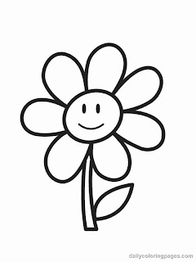____________________.

- ____________________.

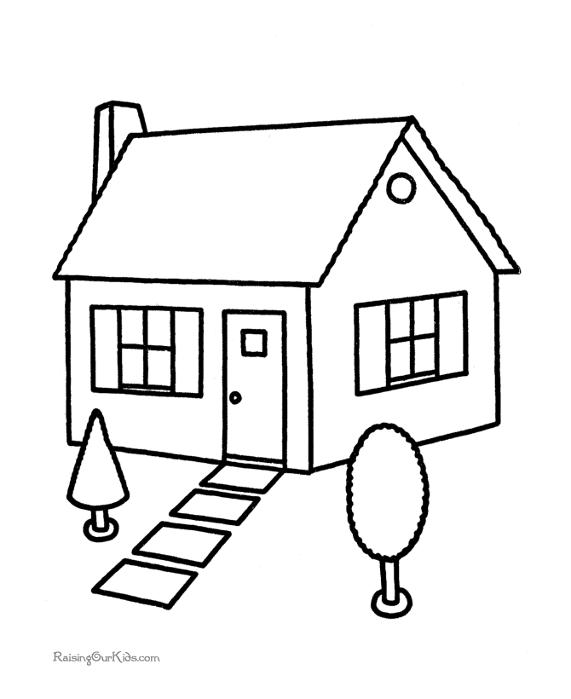
- ____________________.
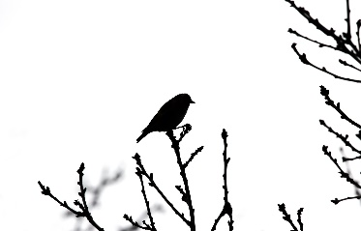

____________________.


- ____________________.
- Circle the odd one. [5]
- Pen orange copy.

- Tiger apple lion.

- Cat dog water.

- Tomato stone potato.

- Eye nose sky.

- Write down any five pronouns. [5]

- ____________________.

- ____________________.

- ____________________.

- ____________________.

- ____________________.

- Write the name of any five action verbs. [10]

- ____________________.

- ____________________.

- ____________________.

- ____________________.

- ____________________.

- Dictation. [5]

- ____________________.

- ____________________.

- ____________________.

- ____________________.

- ____________________.

- Copy as given. [5]
My School’s name is Sarbanam Shikshyalaya.

____________________________________________________

____________________________________________________.

_______________________________________________

____________________________________________________.

_______________________________________________

____________________________________________________.

____________________________________________________.

____________________________________________________.

____________________________________________________.

- Class test. [10]

- Handwriting. [5]

- Oral. [5]

- Assignment. [5]

- Discipline. [5]

- Regularity. [5]

Sarbanam Shikshyalaya
Gokarneshwor-06 Jorpati, Kathmandu
Third Terminal Examination-2079
Grade : UKG FM:100
Subject :Knowledge and PM:40
understanding Time: 2:30 hrs.
Name: Section: Roll.No:
Marks Obtained Sheet
Q.N. | O.M. | Q.N. | O.M. | Q.N. | O.M. | Q.N. | O.M. | Q.N. | O.M.
1. |  | 2. |  | 3. |  | 4. |  | 5.
6. |  | 7. |  | 8. |  | 9. |  | 10.
11. |  | 12. |  | 13. |  | 14. |  | 15.
16. |  | 17. |  | 18. |  | 19. |  | 20.

Total:
In words:

-------------- ---------------- ------------------ ------------------------
Invigilator Examiner Checked By Exam Coordinator

- Write the name of any five living things. [5x1=5]
- ______________________________.
- ______________________________.
- ______________________________.
- ______________________________.
- ______________________________.
- Circle the name of non- living things. [5x1=5]
- Cat pen hen.

- Copy dog boy.

- Girl gug pig.

- Tree mobile goat.

- Eraser piglet fawn.

- Write the name of any five different types of trees. [5x2=10]
- _________________________________.

- _________________________________.

- _________________________________.

- _________________________________.

- _________________________________.

- Write the name of any five Planets. [5x2=10]
- _________________________________.
- _________________________________.
- _________________________________.
- _________________________________.
- _________________________________.
- Match the animals with their babies. [5x1=5]

- Goat chick

- Hen kid

- Lion piglet

- Pig kitten

- Cat cub
- Name the given picture. [5x1=5]

_____________________.

______________________.

_____________________.



- ______________________.

______________________.
- Arrange the jumbled letter. [5x1=5]
- GEG ______________________.

- BUC ______________________.

- NOIL ______________________.

- HNE ______________________.

- CTA ______________________.
- Choose the words below to complete the sentence. [5x1=5]
Earth, Eight, Mercury, Sphere, Cotton
- There are _________________ planets in the solar system.
- The shape of the earth is called a _________________.

- The nearest planet is called _________________.

- I live on a planet called _________________.

- We should wear _________________ clothes in the summer season.
- Draw the picture of small and big trees and colour them.
(5x2=10)

- Write true or false. 5x1=5]
- We should drink clean water. [ ]

- There are eight planets in the solar system. [ ]

- The cow has four legs. [ ]

- We should scold to our friend. [ ]

- An apple is a vegetable. [ ]

- Class test. [10]
- Handwriting. [5]
- Oral. [5]
- Assignment. [5]
- Discipline. [5]
- Regularity. [5]

Sarbanam Shikshyalaya
Gokarneshwor-06 Jorpati, Kathmandu
Third Terminal Examination-2079
Grade : UKG FM:100
Subject :Math PM:40
Time: 2:30 hrs.
Name: Section: Roll.No:
Marks Obtained Sheet
Q.N. | O.M. | Q.N. | O.M. | Q.N. | O.M. | Q.N. | O.M. | Q.N. | O.M.
1. |  | 2. |  | 3. |  | 4. |  | 5.
6. |  | 7. |  | 8. |  | 9. |  | 10.
11. |  | 12. |  | 13. |  | 14. |  | 15.
16. |  | 17. |  | 18. |  | 19. |  | 20.

Total:
In words:

-------------- ---------------- ------------------ ------------------------
Invigilator Examiner Checked By Exam Coordinator

- Write down from 150 to 200. [5]
150

- Write down the Nepali number from १५० to २००. [5]
१५०

- Write the numerical. [5]
- एक _______________.
- नौ _______________.
- पाच _______________.
- एघार _______________.
- बीस _______________.
- Count and write in words. [5]
- 0000000 _______________.
- 000 _______________.
- 0 _______________.
- 0000000000 _______________.
- 00 _______________.

- Write the name of following shapes. [5]

_______________.
b.

_______________.
- Match the following. [5]

- Eighty 20

- Twenty 8

- Thirteen 1

- One 5

- Five 13
- What comes between? [5]
- 40 _______________42.

- 60 _______________ 62.

- 7 _______________ 9.

- 25 _______________. 27.

- 39 _______________ 41.
- Write the number names. [5]
- 10 _______________.
- 20 _______________.
- 40 _______________.
- 25 _______________.
- 8 _______________.

- Put < or > or = sign in box. [5]
- 20 _______________ 25.
- 3 _______________ 3.
- 9 _______________ 20.
- 8 _______________ 8.
- 35 _______________29.
- Add [+] [5]
- 8+4= _______________.

- 10+5= _______________.

- 2+1= _______________.

- 4+3= _______________.

- 9+3= _______________.

- Copy the words. [5]

Sixty six Ninety

_______________. _______________.

_______________. _______________.

_______________. _______________.

- Write the multiplication table of 3 and 6. [10]
3x1=3 | 6x1=6

- Class test. [10]
- Handwriting. [5]
- Oral. [5]
- Assignment. [5]
- Discipline. [5]
- Regularity. [5]
Sarbanam Shikshyalaya
Gokarneshwor-06 Jorpati, Kathmandu
Third Terminal Examination-2079
Grade : UKG FM:50
Subject :Theme PM:20
Time: 1:15 hrs.
Name: Section: Roll.No:
Marks Obtained Sheet
Q.N. | O.M. | Q.N. | O.M. | Q.N. | O.M. | Q.N. | O.M. | Q.N. | O.M.
1. |  | 2. |  | 3. |  | 4. |  | 5.
6. |  | 7. |  | 8. |  | 9. |  | 10.
11. |  | 12. |  | 13. |  | 14. |  | 15.
16. |  | 17. |  | 18. |  | 19. |  | 20.

Total:
In words:

-------------- ---------------- ------------------ ------------------------
Invigilator Examiner Checked By Exam Coordinator

- Write the name of any five sources of water. [5x2=10]

- ___________________________.

- ___________________________.

- ___________________________.

- ___________________________.

- ___________________________.
- Fill in the blanks. [5x1=5]

- S _______ u _______ e _______ t.

- B _______ _______ k.

- T _______ a _______ h _______ r.

- T _______ e _______ e.

- C _______ _______ y.

- कुनै पाच वटा तरकारीहरुको नाम लेख [५x२=१०]

  - __________________।

  - __________________।

  - __________________।

  - __________________।

  - __________________।

- Write the multiplication table of 5. [10]
5x1=5

- Class test [5]
- Handwriting. [2]
- Oral. [2]
- Assignment. [2]
- Discipline. [2]
- Regularity. [2]

BEST OF LUCK…..

